**DESCENDING ORDER**

**EXP NO: 13**

**AIM:**To compute descending order of an array using 8085 processor.

**ALGORITHM:**  
  
1)      Initialize HL pair as memory pointer.  
  
  
2)      Get the count at memory and load it into C register  
  
  
3)      Copy it in D register (for bubble sort (N-1)) time required).  
  
  
4)      Get the first value in A register.  
  
  
5)      Compare it with the value at next location.  
  
  
6)      If they are out of order, exchange the contents of A register  
 and memory.  
  
  
7)      Decrement D register content by 1  
  
  
8)      Repeat step 5 and 7 till the value in D register become zero.  
  
  
9)      Decrement the C register content by 1.  
  
   
10)  Repeat steps 3 to 9 till the value in C register becomes  
 zero.  
  
  
 **PROGRAM:**  
  
  
LOOP: LXI H,3500

MVI D,00  
  
  
MVI C,05  
  
  
LOOP1: MOV A,M  
  
  
INX H  
  
  
CMP M  
  
  
JNC LOOP2  
  
  
MOV B,M  
  
  
MOV M,A  
  
  
DCX H  
  
  
MOV M,B  
  
  
INX H  
  
  
MVI D,01  
  
  
LOOP2: DCR C  
  
  
JNZ LOOP1  
  
  
MOV A,D  
  
  
RRC  
  
  
JC LOOP  
  
  
HLT  
  
  
 **INPUT:**

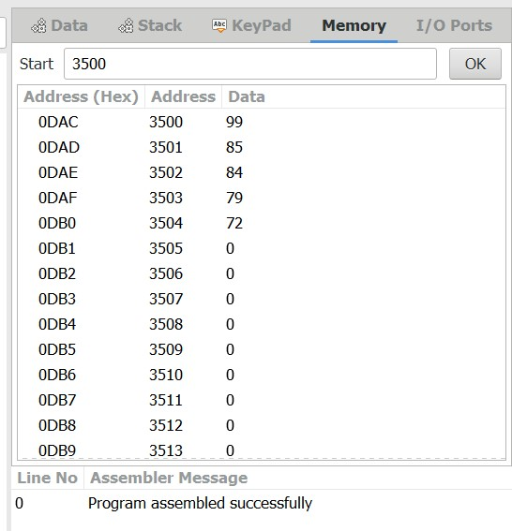  
  
  
  
  
 

**OUTPUT:**  
  
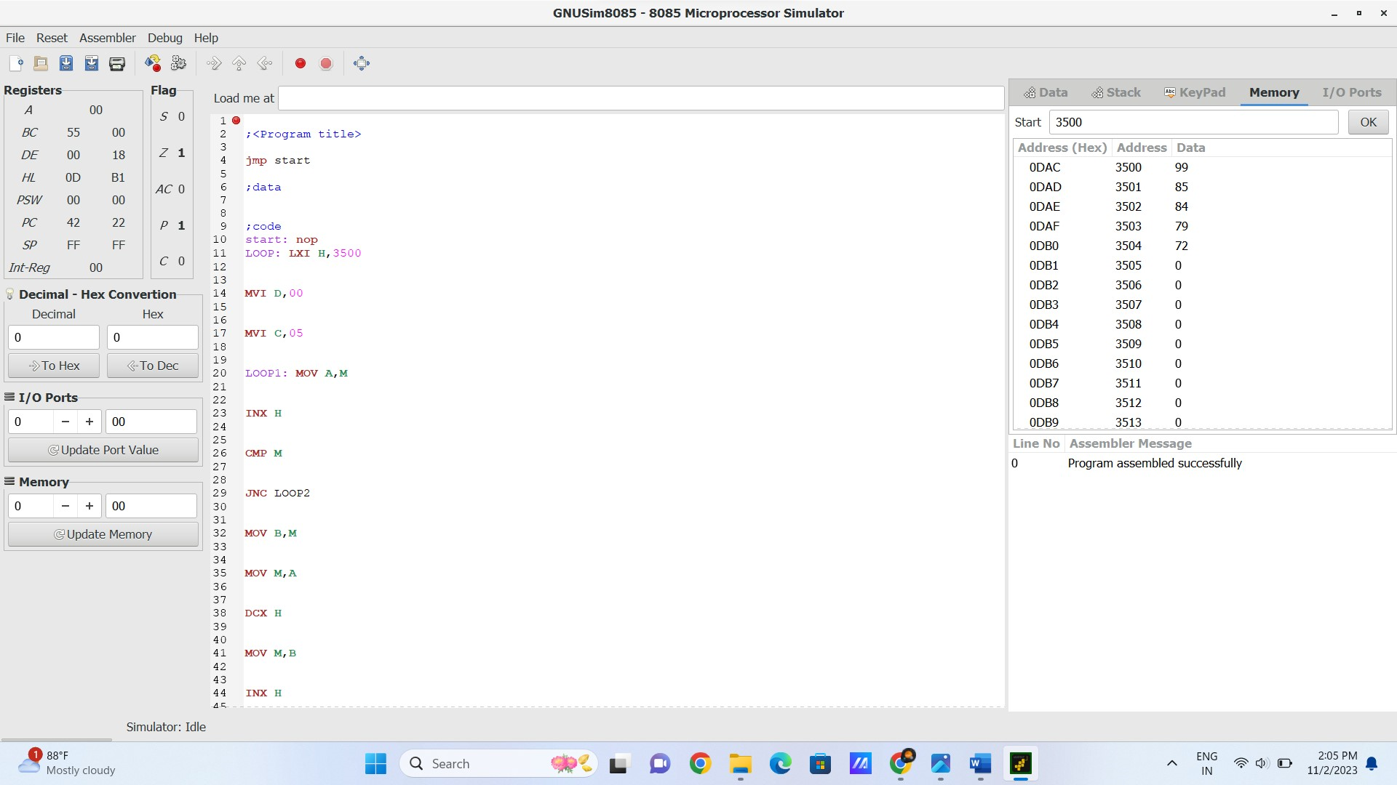  
  
  
  
 **RESULT:**

Thus the program was executed successfully using 8085 processor simulator.